Ear Syringing

https://www.amazon.co.uk/AcuLife-Ear-Removal-Syringe-Packs/dp/B06Y381KC4/ref=sr_1_19?keywords=ear+syringe&qid=1575463591&sr=8-19

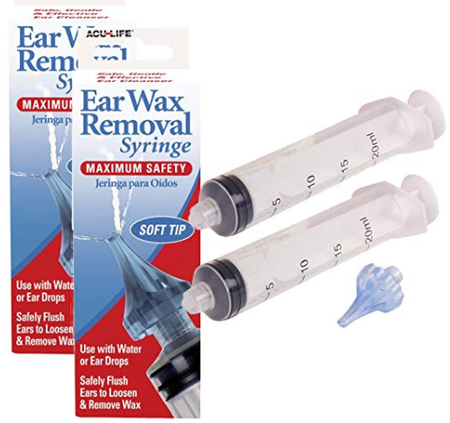

- Flared Design
- Tri-Stream Tip
- Exit Portals
- Safe & Easy to use
- More effective than a bulb syringe

Product description
Size:2 Packs
Unlike traditional bulb ear syringes that can damage the ear if inserted too far, the unique Aculife Ear Wax Removal Syringe features a flared tip design to prevent over insertion while effectively cleaning the ears and preventing ear wax buildup. The unique tip directs fluid to the ear canal walls using a tri-stream directional jet ensuring an even safer and more effective alternative to direct flow syringes.
The ear wax removal syringe is used to effectively dislodge stubborn ear wax and other debris. Exit portals allow for drainage ensuring no pressure build-up occurs and any wax or debris is effectively drained safely away. For ear wax blockages it is advisable to soften the wax prior to syringing with olive oil. This unique product is designed for home use and comes complete with full user instructions. Not to be used with children under 3 years of age.
DISCLAIMER – THIS PRODUCT IS NOT ENDORSED BY THE SURGERY

